Dynamic Knowledge Representation for e-Learning Applications
M. E. S. Mendes and L. Sacks
Department of Electronic and Electrical Engineering, University College London, Torrington Place, London WC1E 7JE, UK
Abstract. This chapter describes the use of fuzzy clustering for knowledge representation in the context of e-Learning applications. A modified version of the Fuzzy c-Means algorithm that replaces the Euclidean norm by a dissimilarity function is proposed for document clustering. Experimental results are presented, which show substantial improvement in the modified algorithm, both in terms of computational efficiency and of quality of the clusters. The robustness of this fuzzy clustering algorithm for document collections is demonstrated and its use for on-line teaching and learning in a complete end-to-end system is explored.
  - Introduction
In recent years, network-based teaching and learning (e-Learning) has become widespread, with bespoke solutions by individual institutions and standardizing initiatives for learning technologies [14]. The work presented in this chapter is in relation with the CANDLE project, a European Commission funded project that is developing an e-Learning service mainly focused on providing a flexible learning environment and on delivering sharable and reusable course material in the area of Telematics, within a standards based framework.


Pedagogical Model
Study
Tracks
Author/
Teacher
Navigation
Engine

Usage
History

Profile
Background
Interests
Achievements
Learning Style
Learner
Knowledge Space
Knowledge
Representation
Framework

Courseware
Database (XML)
Metadata
Fig. 1. Adaptive knowledge-based content navigation for flexible e-Learning
Although e-Learning systems lack face-to-face interaction between teachers and students, they have the major advantage of enabling people to access learning facilities regardless of their location and whenever it is most convenient to them. Large networked repositories of learning material may be accessed by students, but it is necessary to narrow down the available resources to a particular individual based on the learning context, i.e., to take into account learning objectives, pedagogical approaches and profile of the individual learner. This may range from relatively rigid training objectives through to exploratory or research oriented interactions [25] - the system should be flexible enough to accommodate these different learning scenarios. Towards the more exploratory end of the learning spectrum, tools such as an adaptive navigation engine are required to determine which documents are the most relevant for a given student, who wants to learn a particular subject.
In Fig.1, a framework for adaptive knowledge-based content navigation is depicted. The student’s exploration of the content database is constrained by the pedagogical approach defined by the teacher. In a more instructional approach there would be a low degree of freedom as the student would have to follow a specific sequence of links. More flexible approaches should also be supported. However, giving the freedom to explore the whole database would not be a good option because of the ease with which learners can stray away from the original learning goals. A solution is to have a group of related material organized in an abstract knowledge space so that when the student wants to learn more about a given topic, the navigation engine can follow the knowledge space relationships between documents to derive the links relevant to the students’ interests and objectives.
To achieve this, there needs to be a way to classify and organize learning materials in terms of knowledge domains. The proposed approach to this problem is to use fuzzy clustering to dynamically discover document relationships. Such approach is explored in the section 1.2. The remaining sections of this chapter describe the background and experiments with fuzzy clustering for knowledge representation. In section 1.3, details about document representation schemes, distance functions, clustering algorithm and performance evaluation measures are presented. A modified version of the Fuzzy c-Means [4] clustering algorithm is also introduced. In section 1.4, the experiments with fuzzy clustering are presented and analyzed. The integration of the dynamic knowledge representation with adaptive e-Learning systems is described in section 1.5, and the conclusions are presented in section 1.6.
  - Fuzzy Clustering for Knowledge Representation
An abstract knowledge space can be built in several ways. A popular emerging approach is to develop an ontology of the domain, defining a set of concepts and relations between those concepts. In CANDLE, each piece of course material is tagged with metadata according to an extended version of IEEE LOM (Learning Objects Metadata) model [13]. Metadata is descriptive information about resources such as: title, authors, keywords, technical requirements, conditions of use, and such like. CANDLE’s metadata model includes a category to classify courseware according to a pre-defined taxonomy (concepts) to form an ontology of the Telematics domain. By tagging each piece of content with specific concepts, the relationships defined in the ontology can be used to locate related course material. This approach is a major feature of the more general enterprise of the Semantic Web [2,11].
The rich semantic information captured by the ontology facilitates the search of material both for authors and learners. Authors may start from one point in the ontology and follow the appropriate links to locate material with the relationships required for their new courses. The learner may use the ontology for navigation and possibly automated location of content – by following a set of relationships relevant content can be located. The key question with this approach is which ontology to use. Two problems can be foreseen. On the one hand, different experts in a given field are likely to disagree on the correct ontology. On the other hand, in fields like engineering or telematics the true ontology quickly changes through time as the fields develop. Hence, the deployment and maintenance efforts are costly. Similar limitations have been pointed out in the context of the Semantic Web [8]. This provides the motivation to develop a process for dynamic ontology discovery.
Our proposal is to employ fuzzy clustering techniques for discovering the underlying knowledge structure and identifying knowledge-based relationships between learning materials. Fuzzy clustering methods fit in the broad area of pattern recognition. The goal of every clustering algorithm is to group data elements according to some similarity measure so that unobvious relations and structures in the data can be discovered. Information retrieval is one of the fields where clustering techniques have been applied, with the objective of improving search and retrieval efficiency. The use of clustering in this area is supported by the so-called cluster hypothesis [24], which assumes that documents relevant to a given query tend to be more similar to each other than to irrelevant documents and hence are likely to be clustered together. Clustering has also been proposed as a tool for browsing large document collections [9] and as a post-retrieval tool for organizing Web search results into meaningful groups [34]. The organization of online learning material into knowledge domains can be seen as a document clustering problem, as every piece of content is represented as an XML document [5], containing the descriptive metadata. Clustering algorithms can thus be used to automatically discover, sometimes unobvious, knowledge-based content relations from the metadata descriptions.
Agglomerative hierarchical clustering algorithms are perhaps the most popular for document clustering [31]. Such methods have the advantage of providing a hierarchical organization of the document collection but their time complexity is problematic in view of partitional methods such as the k-Means algorithm [19] (also quite used for document clustering). These types of algorithms generate hard clusters in the sense that each document is assigned to a single cluster. With fuzzy clustering multiple memberships in different clusters are allowed. Such algorithms have not been widely explored for document clustering although a study in [16] indicates that the Fuzzy c-Means algorithm can perform at least as well as the traditional agglomerative hierarchical clustering methods.
Given that the goal is to discover the best representation for the actual ontology of the domain, fuzzy clustering techniques offer substantial advantages over their hard clustering counterparts. And the reasons are the following:
- One of the limitations with pre-defined ontologies is the need for consensual definition of the right ontology. For most systems, knowledge can be ambiguous, can vary between experts and evolves through time. Therefore, a fuzzy knowledge space is more likely to represent the “true” underlying knowledge structures.
- The process of tagging learning content with taxonomic terms is the author’s attempt to define the subjects associated with each material. This classification process is intrinsically imprecise, and may differ between authors in their understanding of the keywords and relationships between parts of the system.
The concept behind fuzzy clustering is that of fuzzy logic and the theory of fuzzy sets [33], which provides the mathematical means to deal with uncertainty. Fuzzy clustering brings together the ability to find relationships and structure in data sets with the ability to handle uncertainty and imprecision.
  - Background for the Clustering Experiments
The relevant background for the fuzzy clustering experiments is given in this section. Each step of the knowledge discovery process is depicted in Fig. 2.
Data
Set
Document
Representation
Document
Encoding
Clustering
Algorithm
Pre-processing
Document
Clusters
Knowledge Representation Framework
Fig. 2. Knowledge representation framework
Given a test document collection each document has to be numerically encoded for handling by the clustering algorithm. A suitable document representation has to be generated and some pre-processing may be applied for feature selection. The discovered document relationships are then analyzed to assess the performance of the clustering algorithm. Each of these steps is described in the following sub-sections.
3.1 Document Representation
In order to apply a clustering algorithm to a document collection, there needs to be an appropriate document representation scheme. In the classical models of information retrieval (IR) documents are represented by a set of indexing terms in the form of k-dimensional vectors [1]:
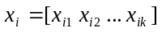 (1.1)
where k is the total number of terms and x_{ij} represents the weight of term j in document x_{i}. The indexing terms are usually obtained through automatic indexing and they represent the words contained in the document collection after stop words removal (i.e. discarding insignificant words like ‘a’, ‘and’, ‘where’, ‘or’) and stemming (i.e. the removal of word affixes such as ‘ing’, ‘ion’, ‘s’) [23,26].
3.2 Pre-processing
In general the total number of indexing terms for a given document collection will be very high. Some of those terms are usually insignificant for document retrieval and also for clustering purposes and they can be excluded by pre-processing, thus reducing the dimensionality of the problem space.
The significance of a term is usually assessed based on its inverse document frequency (IDF), i.e. the number of documents that contain the term. Entropy and specificity are two examples of significance measures [26]. The entropy measure is derived from Claude Shannon’s Information Theory [28], with the premise that the more informative a term is the lower its entropy. Entropy is defined as:
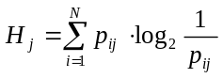, with 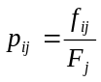 and 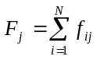 (1.2)
where p_{ij} is the probability of term j appearing in document i and F_{j} is the sum of the frequencies of term j (f_{ij}) in all documents (N). Terms that appear in most documents exhibit high entropy and may be regarded as noise in the clustering process and thus, they may be discarded.
The specificity measure identifies terms that only appear in a small percentage of documents (very specific terms) or terms that appear in almost every document (too general). Such terms are considered irrelevant and can be discarded. The specificity of a term is defined as follows:

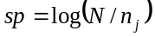 (1.3)

where N is the total number of documents in the collection and n_{j} the number of documents containing term j. These measures provide metric scales for keeping or discarding indexing terms. The sensitivity of the pre-processing will be analyzed in depth in section 1.4.2.
3.3 Document Encoding
The term weights x_{ij} that compose the document vectors as in Eq. (1.1) can be obtained in various ways. In the Boolean model of IR binary term weights are used, i.e. x_{ij}∈{0,1}, that just acknowledge the presence or absence of terms in the document. Alternatively, in the Vector model of IR the weights are a function of the terms frequency [1]. This model has been selected for document encoding discussed here.
In the Vector model, the simplest term weighting scheme, know as tf, uses the term frequencies as weights – x_{ij} = f_{ij}. Another scheme that has proved to perform well, attributes high weights to terms that occur frequently in a small number of documents (i.e. terms that have high specificity) [27]. Such weighting scheme is known as tf×idf. The weights are usually given by the formula in Eq. (1.4) or variations of this formula.
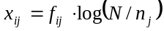 (1.4)
Longer documents contain more words and consequently higher term weights. But in IR systems, documents with different lengths should have equal chances of being retrieved. For this reason, vector length normalization is usually applied (i.e. ||x_{ij}||=1). For clustering applications, such normalization should also be made.

3.4 Clustering Algorithm
Considering the requirements of the knowledge representation framework, the Fuzzy c-Means algorithm (FCM) [4] is used. It is perhaps the most popular fuzzy clustering technique and it generalizes a popular document clustering algorithm - the hard k-Means algorithm [19]. The later produces a crisp partition of the data set whereas the former generates a fuzzy partition: documents may be assigned to several clusters simultaneously. A description of the algorithm follows.
Fuzzy c-Means Clustering Algorithm
Given a data set with N elements each represented by k-dimensional feature vector, the Fuzzy c-Means algorithm takes as input a (N×k) matrix X=[x_{i}]. It requires the prior definition of the final number of clusters c (1<c<N), the choice of the fuzzification parameter m (m>1) and the selection of a distance function ||⋅||, the most common being the Euclidean norm.
The algorithm runs iteratively to obtain the cluster centers (or prototypes) – V=[v_{α}]: (c×k) – and a partition matrix – U=[u_{αi}]: (c×N) – which contains the membership of each data element in each of the c clusters. Both the cluster centers and the partition matrix are computed to minimize the following objective function:
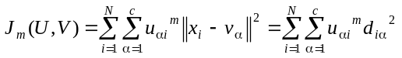 (1.5)
The FCM algorithm starts with a random initialization of the partition matrix subject to the following constraints:

- 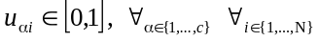 (1.6)
- 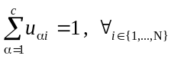 (1.7)
- 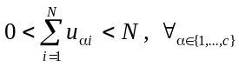 (1.8)
At each iteration t the grades of membership and the cluster centers are updated according to Eqs. (1.9) and (1.10) respectively:
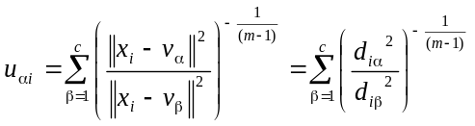 (1.9)

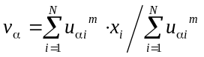 (1.10)
The algorithm ends when the termination criterion is met (||U^{(t+1)}U^{(t)}||<ε) or the maximum number of iterations is achieved (t+1>t_{max}).
Selection of the Distance Function
Most clustering algorithms group related data elements based on some notion of distance/proximity between elements. Hence, the choice of a particular distance function should reflect the nature of the data set.
Although Euclidean distance is usually applied in the FCM algorithm, it is not the most suitable for measuring the proximity of documents vectors, which tend to be very sparse and high-dimensional. To justify this statement we give the following example. Let us consider two documents x_{A} and x_{B} that are indexed with a set of k terms T. Let us also assume that most terms in T, say k’, appear neither in x_{A} nor in x_{B}. Also that x_{A} and x_{B} have no terms in common. Since the two document vectors agree in k’ dimensions in which they both have zero term frequencies, their Euclidean distance may be relatively small when in fact x_{A} and x_{B} are totally dissimilar. Hence, the problem with the Euclidean norm is that the non-occurrence of the same terms in both documents is handled in similar way as the co-occurrence of terms.
In the Vector model of information retrieval the degree of similarity between query vectors and document vectors is usually evaluated as the inner product of the two vectors [1]:
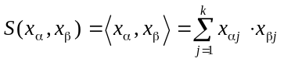 (1.11)
Considering the case when both x_{α} and x_{β} are normalized to unit length (i.e. ||x_{α}||=||x_{β}||=1) this similarity function S represents the cosine of the angle between the document vector x_{α} and the query vector x_{β} - reason why it is also referred to as the cosine measure. This measure exhibits the following properties:
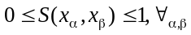 (1.12)
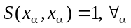 (1.13)
A simple transformation in Eq. (1.11) can be made to obtain a dissimilarity function D:
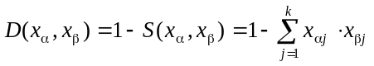 (1.14)
In this case,
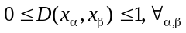 (1.15)
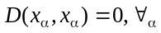 (1.16)
Referring back to the example of the two documents, x_{A} and x_{B}, this function would result in the maximum value, i.e. D(x_{A},x_{B})=1, indicating total dissimilarity.
Relation between Euclidean Distance and Dissimilarity
The Euclidean distance is an inner product induced norm defined by the following equation:
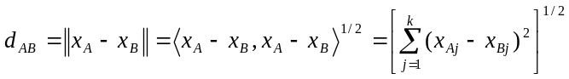 (1.17)
When x_{A} and x_{B} are normalized vectors it follows that
(1.18)
which reveals that the squared Euclidean distance between two unit length vectors is directly proportional to the dissimilarity function defined in Eq. (1.14):
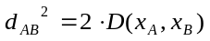 (1.19)
The previous remark might suggest that applying the Fuzzy c-Means algorithm to a document collection, with documents represented as normalized term vectors, will produce equivalent results either using the Euclidean norm or the dissimilarity function. But this is not the case because the cluster prototype vectors are not normalized in the original algorithm (see section 1.4.2 for a comparative analysis). Therefore, the squared Euclidean distance between document vectors and cluster prototypes will not follow Eq. (1.19).
  - Hyperspherical Fuzzy c-Means Algorithm
We have applied the dissimilarity function introduced in the previous section for clustering normalized document vectors using the Fuzzy c-Means approach. The objective function in Eq. (1.5) has been modified by replacing the squared norm with the function defined in Eq. (1.14):
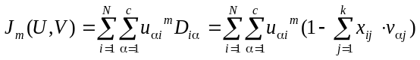 (1.20)
A new update expression for the clusters prototypes has to be defined in order to use the dissimilarity function such that properties (1.15) and (1.16) hold. This implies that the cluster prototype vectors need to be normalized. Consequently, a constraint for the optimization of J_{m} is introduced:
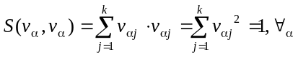 (1.21)
Using the method of the Lagrange multipliers [3] it is possible to minimize Eq. (1.20) subject to constraints, as this method converts constrained optimization problems into unconstrained ones. Besides constraint from Eq. (1.21), constraints (1.6), (1.7) and (1.8) still need to be regarded. Since the optimization is made taking U and V separately, minimizing the function in Eq. (1.20) with respect to u_{αi} (v_{α} fixed) leads to a similar result of that in Eq. (1.9), the only difference being the replacement of d_{iα}² and d_{iβ}² by D_{iα} and D_{iβ},. The expression for u_{αi} is now:
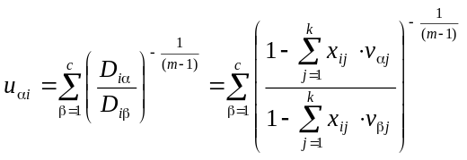 (1.22)
To minimize Eq. (1.20) with respect to v_{α} (u_{αi} fixed) with constraint (1.21), the Lagrangian function is defined as:
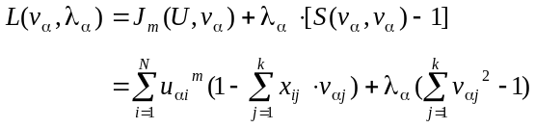 (1.23)
where λ_{α} is the Lagrange multiplier. To convert the optimization problem into an unconstrained problem the derivative of the Lagrangian function is taken,
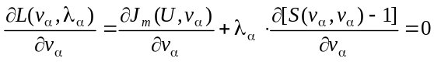 (1.24)
that is equivalent to,
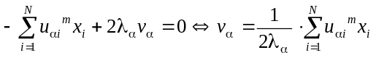 (1.25)
and by applying constraint from Eq. (1.21) follows,
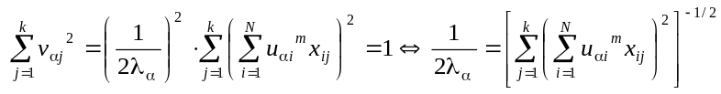 (1.26)
Finally, replacing 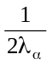 in Eq. (1.25) leads to:
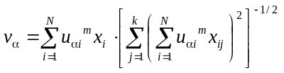 (1.27)
The modified algorithm runs similarly to the original FCM differing only on the expressions to update v_{α}. It can be shown that the new expression for v_{α} represents a normalization of the original v_{α} as defined in Eq. (1.10).
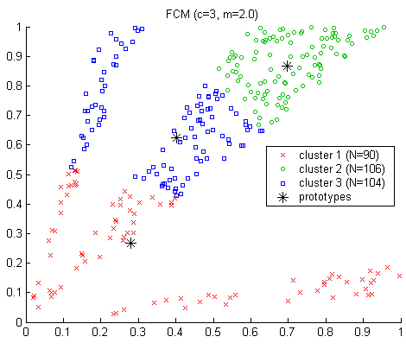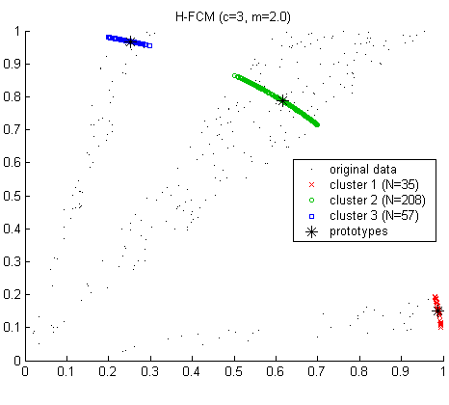
a) b)
Fig. 3. Clustering of points in a bi-dimensional space using: a) FCM and b) H-FCM with normalized data vectors
For future reference, the modified algorithm will be labeled as Hyperspherical Fuzzy c-Means (H-FCM), since both data vectors and cluster centers lie in a k-dimensional hypersphere of unit radius. To illustrate this, consider a bi-dimensional data set that can be partitioned into three clusters of highly similar data elements (i.e. any pair of elements in the cluster has a high cosine measure). In Fig. 3, the spatial distribution of the data elements is shown and the clusters discovered with a) FCM and b) H-FCM can be discriminated by the different plot markers.
The H-FCM plot shows both cluster prototypes and normalized data elements located in a circle of unit radius. H-FCM distributes the data elements among the clusters following a criterion of minimum dissimilarity to the cluster prototypes, whereas with FCM this does not happen. The FCM graph and the data in Table 1 show that cluster 1 includes elements which are quite dissimilar (D = 0.7016).
As a final note: applying FCM for document clustering might lead to high pairwise dissimilarities within clusters, which means that documents sharing very few terms might be grouped together. Such problem makes the case for using the Hyperspherical Fuzzy c-Means algorithm in preference. Results of a performance comparison between FCM and H-FCM are presented in section 1.4.2.
Table 1. Maximum (max), average (avg) and standard deviation (stdev) of the pairwise dissimilarity between elements within each cluster
 | FCM |  |  | H-FCM
Dissimilarity | max (D_{ij}) | avg (D_{ij}) | stdev(D_{ij}) | max(D_{ij}) | avg(D_{ij}) | stdev(D_{ij})
Cluster 1 | 0.7016 | 0.2099 | 0.0629 | 0.0047 | 9.97×10⁻⁴ | 4.63×10⁻⁴
Cluster 2 | 0.0273 | 0.0046 | 0.0022 | 0.0307 | 5.20×10⁻³ | 2.20×10⁻³
Cluster 3 | 0.1586 | 0.0382 | 0.0138 | 0.0052 | 6.40×10⁻⁴ | 3.72×10⁻⁴
3.6 Performance Evaluation
The performance of clustering algorithms is generally evaluated using internal performance measures, i.e. measures that are algorithm dependent and do not contain any external or objective knowledge about the actual structure of the data set. This is the case of the many validity indexes for the Fuzzy c-Means algorithm. When there is prior knowledge on how clusters should be formed, external performance measures (algorithm independent) can be used to compare the clustering results with the benchmark. The next sub-sections cover these two types of evaluation measures.
Internal Performance Measures: Validity Indexes for the FCM
As discussed in section 2, the document clusters should be fuzzy so that uncertainty and imprecision in the knowledge space can be handled. However, there needs to be a compromise between the amount of fuzziness and the capability to obtain good clusters and meaningful document relationships. It is known that increasing values of the fuzzification parameter - m - lead to a fuzzier partition matrix. Thus, this parameter can be adjusted to manage this compromise. Establishing the appropriate values for m requires the use of a validity index.
There are several validity indexes for the fuzzy c-means algorithm that are used to analyze the intrinsic quality of the clusters. A simple cluster validity measure that indicates the closeness of a fuzzy partition to a hard one is the Partition Entropy (PE) [4], defined as:
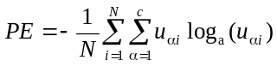 (1.28)
The possible values of PE range from 0 – when U is hard – to log_{a}(c) – when every data element has equal membership in every cluster (u_{αi} = 1/c). Dividing PE by log_{a}(c) normalizes the value of PE to range in the [0,1] interval.
The Xie-Beni index [32] evaluates the quality of the fuzzy partition based on the compactness of each cluster and separation between cluster centers: the assumption is that the more compact and separated the clusters are the better. This index is defined as follows:
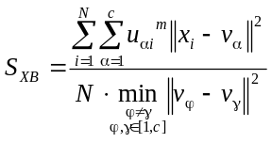 (1.29)
If the minimum distance between any pair of clusters is too low, then S_{XB} will be very high. Hence, normally a good partition corresponds to a low value of S_{XB}.
Both validity indexes were derived for the FCM but they are still applicable for the H-FCM algorithm. A simple modification is required in the expression for S_{XB} to replace the squared distance ||⋅||² with the dissimilarity function of Eq. (1.14). No change is required for PE since it is only a function of the membership matrix.
External Performance Measures: Precision, Recall, F-Measure
Precision and recall are two popular measures for evaluating the performance of information retrieval systems [1,24]. They represent the fraction of relevant documents out of those retrieved in response to a query and the fraction of retrieved documents out of the relevant ones, respectively. Similar measures have been proposed for classification systems [17]. The purpose of such systems is to classify data elements given a known set of classes. In this context, precision represents the fraction of elements assigned to a pre-defined class that indeed belong to the class; and recall represents the fraction of elements that belong to a pre-defined class that were actually assigned to the class. Precision and recall can be equally used to evaluate clustering algorithms, which are in fact unsupervised classification systems, when a clustering benchmark exists. For a given cluster α and a reference cluster β, we define precision (P_{αβ}) and recall (R_{αβ}) as follows:
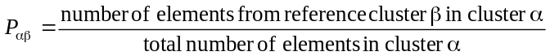 (1.31)

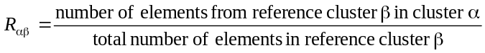 (1.32)
These two measures can be combined into a single performance measure – the F-measure [18,24] – that is defined as:

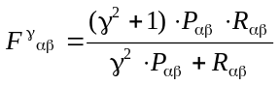 (1.33)

where γ is a parameter that controls the relative weight of precision and recall (for equal contribution, γ=1 is used). The individual P_{αβ}, R_{αβ} and F_{αβ} measures are averaged to obtain overall performance measures P, R and F.
For fuzzy clusters, the maximum membership criterion can be applied to count the number of data elements in each cluster for the P_{αβ} and R_{αβ} calculation. In the case of maximum fuzziness, i.e. all elements with equal membership in all the clusters, precision and recall will be P_{αβ}= N_{β}/N and R_{αβ}=1, ∀_{α,β} (where N_{β} is the total number of documents in reference cluster β and N the collection size).
  - Fuzzy Clustering Experiments
The main objectives of the document clustering experiments were to investigate the suitability of fuzzy clustering for discovering good document relationships and also to carry out a performance analysis of the H-FCM compared with the original FCM. In this section the experimental results are reported and analyzed.
  - Data Set Description
Since the CANDLE database was not yet available for these clustering trials, a familiar document collection was selected, a subset of IETF’s RFCs (Request For Comments) documents. These documents describe protocols and policies for the Internet and the ones chosen were those describing Internet standards.
Each document was automatically indexed for keyword frequency extraction. Stemming was performed and stop words were removed (see section 1.3.1). Document vectors like in Eq. (1.1) were generated and organized as rows of a (N×k) matrix, where N=73 was the collection size and k=12690 was the total number of indexing terms. For the experimental trials two matrices were created, one for each of the term weighting schemes described in section 1.3.3 (tf and tf×idf).
A clustering benchmark was manually created based on our knowledge of the documents’ content and also on the indexing information found in [30]. The RFCs were distributed into six fairly homogeneous clusters although a few documents were very generic and could have been attributed to multiple clusters.
4.2 Experimental Results
Performance Comparison between FCM and H-FCM
The goal of the first experiment was to investigate whether the Hyperspherical Fuzzy c-Means (H-FCM) algorithm was able to generate a good partition of the document collection and how it compared to the original Fuzzy c-Means (FCM) algorithm. The number of clusters was set to c=6 (as the benchmark indicated), the convergence threshold to ε=10⁻⁴ and the maximum number of iterations to t_{max}= 300. FCM and H-FCM were applied to both the tf data and the tf×idf data (in the H-FCM case, the data vectors were normalized to unit length). The experiment was repeated for increasing values of the fuzzification parameter – m[1.10,1.50].
The results are analyzed based on internal and external performance measures (Figs. 4 to 6 and 7 to 9, respectively). The graphs show that in general the tf data leads to slightly better results than the tf×idf data, both in the FCM case and in the H-FCM case. With the tf data matrix, lower Partition Entropy and lower values of the Xie-Beni index were obtained. Furthermore, both algorithms converge slightly faster with this data. Regarding the quality of the clusters, there are no significant differences in the Precision, Recall and F¹ measures of each algorithm.

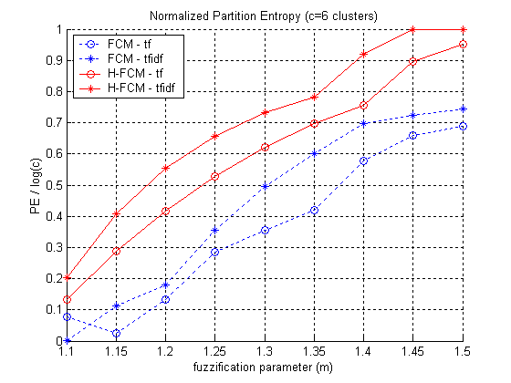
Fig. 4. Internal Performance Measure: normalized Partition Entropy
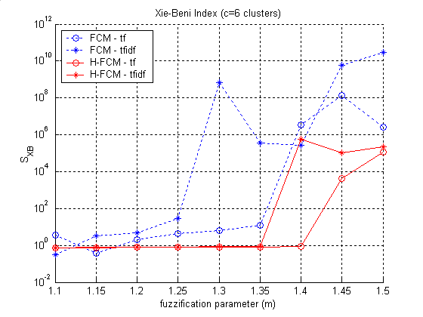
Fig. 5. Internal Performance Measure: Xie-Beni index
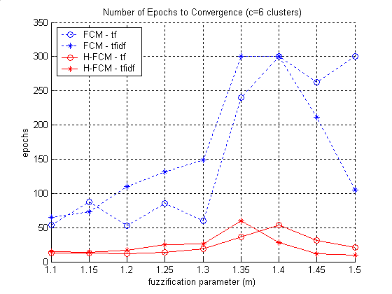
Fig. 6. Internal Performance Measure: number of epochs until convergence

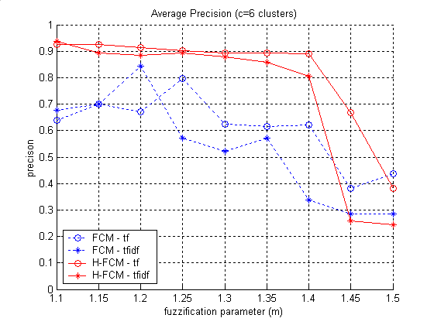
Fig. 7. External Performance Measure: average Precision
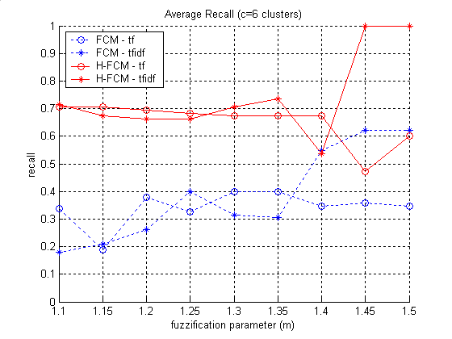
Fig. 8. External Performance Measure: average Recall
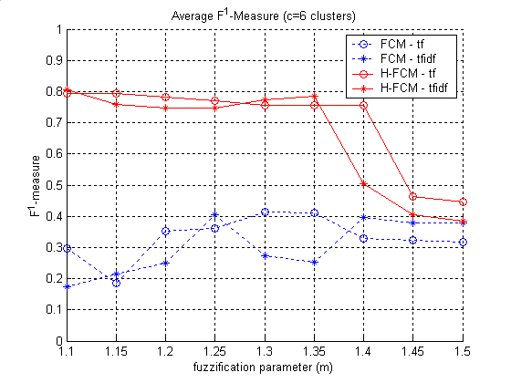
Fig. 9. External Performance Measure: average F¹-Measure

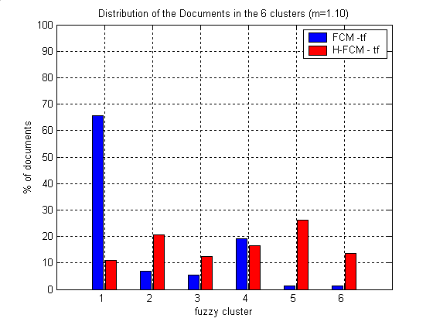
Fig. 10. Percentage of documents attributed to each of the 6 clusters (when m=1.10)

Comparing the performance of both algorithms, the results show that H-FCM performs significantly better than the original FCM. From the PE graph (Fig. 4), it may seem that the H-FCM results are worse than the FCM ones because the former produces fuzzier document clusters for a fixed m. However, the S_{XB} graph (Fig. 5) indicates that the H-FCM clusters are more compact and more clearly separated; and that this is true for a wider range of the fuzzification parameter (m∈[1.10,1.40]). A significant advantage of the H-FCM algorithm is its execution time. It is evident from Fig. 6 that H-FCM converges much faster than FCM. In both cases, the number of iterations for convergence increases with m until maximum Partition Entropy is reached, point after which it starts decreasing again. Furthermore, the external performance graphs prove that the quality of the six clusters (considering the benchmark) is significantly better with H-FCM. Both Precision (Fig. 7) and Recall (Fig. 8.) are quite high in the same range of m values where S_{XB} is low. Conversely, FCM exhibits low Recall which means that very few documents of the reference clusters are attributed to the corresponding fuzzy clusters. In fact, with m set to 1.10 (close to the hard case) around ~66% of the documents were assigned to a single cluster by the FCM algorithm, as the graph in Fig. 10 shows.
FCM vs. H-FCM with Normalized Document Vectors
In section 1.3.4, the relationship between the squared Euclidean norm and the dissimilarity function was established. It was shown that they were equivalent for unit length documents vectors. The goal of this experiment is to demonstrate that despite the equivalence, FCM and H-FCM produce different results since in the FCM case the cluster centers are not normalized.
In Fig. 11, the Partition Entropy plots show that FCM with normalized data vectors reaches maximum fuzziness even for very low values of m, which means that it fails to find any structure in the document collection. Although for m<1.15 the quality of the clusters is comparable with the H-FCM case (see Fig. 13), FCM is still much slower than the H-FCM algorithm (see Fig. 12). The results prove that the dissimilarity function is in fact more suitable than the Euclidean norm for document clustering.
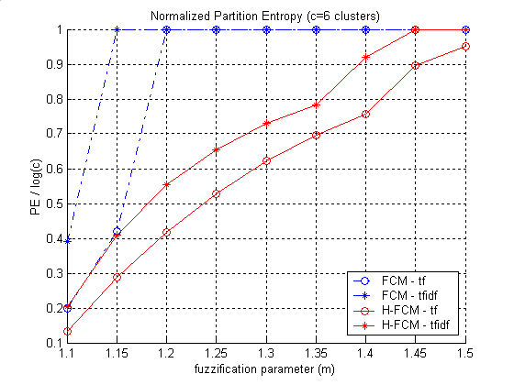
Fig. 11. Normalized Partition Entropy (with normalized document vectors)
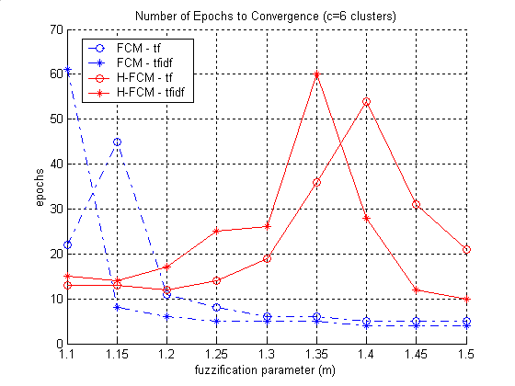
Fig. 12. Number of epochs until convergence (with normalized document vectors)
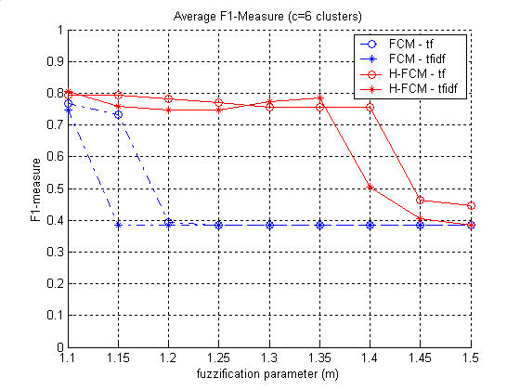
Fig. 13. Average F¹-Measure (with normalized document vectors)

Pre-processing Effects on the H-FCM Results
The aim of this last experiment was to analyze the effects of pre-processing in the H-FCM results. After automatically indexing the document collection, several thresholds for the entropy and specificity filters (discussed in section 1.3.2) were set. For each threshold, a tf matrix was generated and the H-FCM algorithm was applied. Indexing terms were discarded according to the following criteria:
- terms with entropy above a given threshold τ⋅H_{max} (where H_{max} is the theoretical maximum entropy, that occurs for terms with equal probability in every document),
- terms that appeared in a high percentage of documents (indexing terms with specificity below a given threshold)
- and terms that appeared in a small percentage of documents (with specificity above a given threshold).
Each of these filters was considered separately in the experiment.
Fig. 14 shows the average F¹-Measure obtained using H-FCM for different values of the fuzzification parameter. The graph contains the results of the clustering algorithm after entropy pre-processing. With this filter the dimensionality of the document vectors was reduced to k=12627, 12203, 12040, 11837, 11406, 11133, 10803 and 10417 terms, for values of τ equal to 0.75, 0.60, 0.55, 0.50, 0.40, 0.35, 0.30 and 0.25, respectively. It can be observed that for low values of m the quality of the clusters increases slightly for entropy thresholds above 0.55⋅H_{max} but as more terms are removed the results degrade considerably. This means that the presence of terms with very high entropy does not have significant impact on the clustering results and that terms with medium entropy should not be eliminated, since it degrades the performance of the algorithm.
Figs. 15 and 16 show the average F¹-Measure obtained using H-FCM for different values of the fuzzification parameter after pre-processing with the specificity filter. In the first case, terms present in more than 57%, 44%, 34%, 21%, 16% and 12% of the documents were discarded, reducing the dimensionality of the document vectors to k=12754, 12690, 12582, 12253, 12094 and 11889, respectively. From the plots in Fig. 15, it can be observed that keeping terms which are very common does not degrade the clustering results. In the second case, terms which appeared only in 1, 2, 3, 4, 6, 7 and 8 documents were removed, reducing k to 4298, 2906, 2250, 1900, 1631, 1300 and 1192, respectively. From the plots in Fig. 16 it can be observed that removing terms which are very specific does not practically change the F¹-Measure. Such filter produces obvious benefits regarding memory and CPU requirements since a significant dimensionality reduction is achieved (by a factor of 10 with the current document collection).

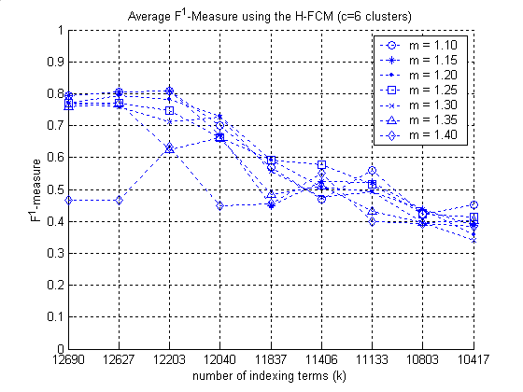
Fig. 14. Average F¹-Measure vs. number of indexing terms – effects of the entropy filter (exclusion of terms with entropy above a fixed threshold)
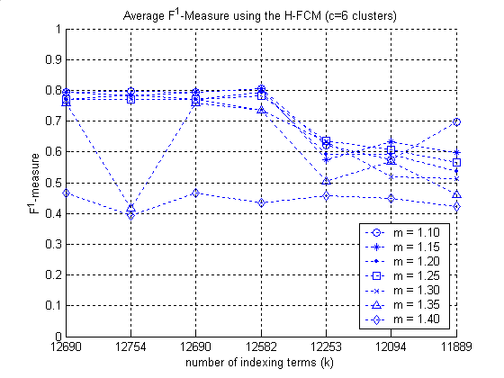
Fig. 15. Average F¹-Measure vs. number of indexing terms – effects of the specificity filter (exclusion of terms with specificity below a fixed threshold)
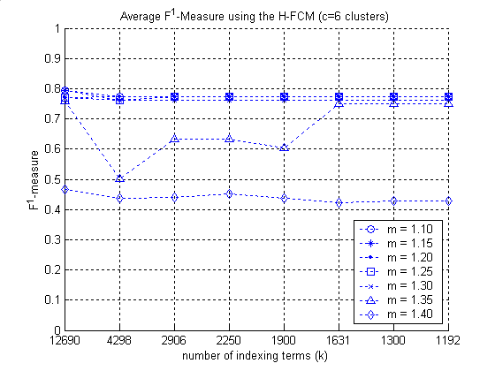
Fig. 16. Average F¹-Measure vs. number of indexing terms – effects of the specificity filter (exclusion of terms with specificity above a fixed threshold)

  - Adaptive Knowledge-based e-Content Navigation
Adaptive content navigation in e-Learning applications has been introduced in section 1.1. Here, the integration of the dynamic knowledge representation framework in such adaptive systems is discussed.
In general, adaptive navigation systems enable personalized access to hyper-linked information. Adaptation in hypermedia systems can be provided at two different levels: at the presentation-level and at the link-level [10]. Presentation-level adaptation deals with issues like how to display the content of a page to a particular user, which information should be shown, which should be available on request, and so on. Link-level adaptation deals with the discovery and display of relevant links to the individual user. Although both kinds of adaptation should be present in e-Learning applications that aim at providing flexible learning environments, link-level adaptation is particularly important to guide students throughout their learning path. There are two principal approaches to dynamically define the links. One is to log the user’s actions so that the system can suggest links based on past information. The other approach keeps a record of the user’s current knowledge and interests in a profile and then search for pages that match the individuals’ needs.
There are several adaptive educational hypermedia systems that implement link-level adaptation [6,7,22,29]. The basic mechanism for adapting content to each student is based on the representation of both domain knowledge (domain model) and student knowledge level (student model) and uses the notion of pre-requisites and outcomes. Pre-requisites are basically the set of concepts a user needs to know to access a document (or online course) and the outcomes are the set of concepts he/she is expected to acquire after reading (or completing) it. The system then analyses the student’s current background (stored in the profile as weighted concepts) to determine which links should be made available.
The domain model is usually static and manually created by experts in the area. By replacing the static model with the dynamic knowledge space obtained with fuzzy clustering, the same adaptation mechanisms can be applied. The use of document clustering for adaptively linking resources has been proposed in [12]. The approach described in this paper employs a hard clustering algorithm and adapts links in context of the user’s interests and of the documents’ contents. The advantage of having fuzzy clusters instead is that links can be sorted by degree of relevance, computed from the fuzzy memberships, and unobvious links may be revealed.
  - Conclusions
Fuzzy clustering has been proposed for dynamic knowledge representation to support flexible content exploration in e-Learning systems. A modified version of the Fuzzy c-Means (FCM) clustering algorithm was derived – the Hyperspherical Fuzzy c-Means (H-FCM) – to replace the Euclidean norm by a dissimilarity function common in traditional information retrieval systems. The experiments carried out with a test document collection showed that the dissimilarity function is a better measure of document proximity than the Euclidean norm. The results indicate that the FCM algorithm produces poor clusters either with or without normalizing the document vectors to unit length. In contrast, H-FCM is able to discover good document clusters for different levels of fuzziness. It was observed that increasing the fuzziness parameter m to a certain level did not affect significantly the quality of the H-FCM clusters. This means that although the membership of documents in other clusters increases with m, documents still have maximum membership in the right cluster. Therefore, fuzziness uncovers the possibility to associate different clusters representing different concepts. It was also observed that the H-FCM algorithm is much faster to converge than the FCM algorithm, which is an important feature considering its applicability to larger document collections.
Regarding the encoding of document vectors no advantages were found in using the tf×idf scheme, as with the tf scheme slightly better results were obtained both with FCM and H-FCM. This means that the clustering algorithms actually performed slightly better when the test documents were encoded independently of the entire document collection. This result suggests that in systems like CANDLE, where new learning material is frequently being created and added to the system, it may not be necessary to re-encode every document each time new content is stored in the database. Furthermore, with sequential or incremental algorithms re-clustering of the whole database may not be required each time a document is added.
The experiments with the RFC collection using different pre-processing filters showed that the H-FCM is robust to pre-processing. Eliminating terms which are very specific to very few documents has almost no impact in the clustering results while reducing significantly the dimensionality of the document vectors and consequently reducing memory and CPU requirements. Likewise, filtering out terms that appear in many documents or that have high entropy does degrade the quality of the clustering results. Both the entropy and specificity filters require information about the entire document collection and therefore, every time the collection grows pre-processing and clustering have to be re-done since terms discarded previously may then be deemed important. Nevertheless, the results showed that the H-FCM algorithm performs equally well without discarding any terms.
  - Acknowledgement
This work has been supported by the Portuguese Foundation for Science and Technology (FCT - Fundação para a Ciência e a Tecnologia) through the PRAXIS XXI doctoral scholarship programme.

  - References
1. Baeza-Yates R, Ribeiro-Neto B (1999). Modern Information Retrieval. Addison Wesley, ACM Press, New York
2. Berners-Lee T, Hendler J, Lassila O (2001). The Semantic Web - A new form of Web content that is meaningful to computers will unleash a revolution of new possibilities. Scientific American, vol 284, no 5, pp 34-43, May 2001
3. Bertsekas DP (1995). Nonlinear Programming. Athena Scientific, Belmont, Massachusetts
4. Bezdek JC (1981). Pattern Recognition with Fuzzy Objective Function Algorithms. Plenum Press, New York
5. Bray T, Paoli T, Sperberg-McQueen CM, Maler E (2000). XML - eXtensible Markup Language v1.0. W3C Consortium, Oct. 2000. Available at: http://www.w3.org/TR/ /2000/REC-xml-20001006
6. Brusilovsky P, Eklund J, Schwarz E (1998). Web-based education for all: A tool for developing adaptive courseware. Computer Networks and ISDN Systems, vol 30, no 1-7, pp 291-300, Apr. 1998
7. Calvi L, De Bra P (1997). Improving the usability of hypertext courseware through adaptive linking. Proceedings of the 8th ACM Conference on Hypertext and Hypermedia, HT’1997, pp 224-225, Apr. 1997
8. Cherry, SM (2002). Weaving a web of ideas. IEEE Spectrum, vol 39, no 9, pp 65 -69, Sep. 2002
9. Cutting DR, Karger DR, Pedersen JO, Tukey JW (1992). Scatter/Gather: a cluster-based approach to browsing large document collections. Proceedings of the 15th Annual International ACM SIGIR Conference on Research and Development in Information Retrieval, SIGIR’92, pp 318-329, Jun. 1992
10. De Bra P, Brusilovsky P, Houben GJ (1999). Adaptive hypermedia: from systems to framework. ACM Computing Surveys, vol 31, no 4es, Dec. 1999.
11. Decker S, Melnik S, van Harmelen F, Fensel D, Klein M, Broekstra J, Erdmann M, Horrocks I (2000). The semantic web: the roles of XML and RDF. IEEE Internet Computing, vol 4, no 5, pp 63-73, May 2000
12. El-Beltagy SR, Hall W, De Roure D, Carr L (2001). Linking in context. Proceedings of the 12th ACM Conference on Hypertext and Hypermedia , HT’2001, pp 151-160, Aug. 2001
13. IEEE Learning Object Metadata Working Group (2000). Draft Standard for Learning Object Metadata. IEEE P1484.12/D5, Nov. 2000. Available at: http://ltsc.ieee.org/doc/ wg12/LOM_ WD5.pdf.
14. IEEE Learning Technology Standards Committee (LTSC): http://ltsc.ieee.org/
15. Klawonn F, Keller A (1999). Fuzzy clustering based on modified distance measures. Proceedings of the Third International Symposium on Intelligent Data Analysis, IDA’99, LNCS 1642, pp 291-301, Aug. 1999
16. Kraft DH, Chen J, Mikulcic A (2000). Combining fuzzy clustering and fuzzy inference in information retrieval. Proceedings of the 9th IEEE International Conference on Fuzzy Systems, FUZZ IEEE 2000, vol 1, pp 375-380, May 2000
17. Lewis DD (1991). Evaluating text categorization. Proceedings of the Speech and Natural Language Workshop, pp 312-318, Feb. 1991
18. Lewis DD and Gale WA (1994). A sequential algorithm for training text classifiers. Proceedings of the Seventeenth Annual International ACM-SIGIR Conference on Research and Development in Information Retrieval, SIGIR 94, pp 3-12, Aug. 1994
19. MacQueen J (1967). Some methods for classification and analysis of multivariate observations. Proceedings of the Fifth Berkeley Symposium on Mathematics, Statistics and Probability, vol 1, pp 281-296
20. Mendes MES, Sacks L (2001). Dynamic knowledge representation for e-Learning applications. In: Proceedings of the 2001 BISC International Workshop on Fuzzy Logic and the Internet, FLINT 2001, Memorandum No. UCB/ERL M01/28, pp 176-181, U. C. Berkeley, Aug. 2001
21. Miyamoto, S (2001). Fuzzy multisets and fuzzy clustering of documents. Proceedings of the 10th IEEE International Conference on Fuzzy Systems, FUZZ IEEE 2001, vol 2, pp 1191-1194, Dec. 2001
22. Pilar da Silva D, van Durm R, Duval E, Olivié H (1997). A simple model for adaptive courseware navigation. Proceedings of INFWET ’97, Nov. 1997
23. Porter M (1980). An algorithm for suffix stripping. Program, vol 14, no 3, pp 130-137, Jul. 1980
24. van Rijsbergen CJ (1979). Information Retrieval. 2nd Edition, Butterworth, London
25. Sacks L, Earle A, Prnjat O, Jarrett W, Mendes M (2002). Supporting variable pedagogical models in network based learning environments. Proceedings of the 2nd IEE Annual Symposium on Engineering Education, vol 1, pp 22/1-22/6, Jan. 2002
26. Salton G (1975). A Theory of Indexing. Society for Industrial and Applied Mathematics, Philadelphia
27. Salton G, Allan J, Buckley C (1994). Automatic structuring and retrieval of large text files. Communications of the ACM, vol 37, no 2, pp 97-108, Feb. 1994
28. Shannon CE (1948). A mathematical theory of communication. The Bell System Technical Journal, vol 27, pp 379-423 and 623-656, Jul. and Oct. 1948
29. Weber G, Specht M (1997). User modelling and adaptive navigation support in WWW-based tutoring systems. Proceedings of the 6th International Conference on User Modelling, UM’97, pp 289-300, Jun. 1997
30. Wheeler L. IETF RFC Index. Available at: http://www.garlic.com/~lynn/rfcietf.htm
31. Willett P (1988). Recent trends in hierarchical document clustering: a critical review. Information Processing and Management, vol 24, no 5, pp 577-597, 1988
32. Xie XL, Beni GA (1991). A validity measure for fuzzy clustering. IEEE Transactions on Pattern Analysis and Machine Intelligence, vol 13, no 8, pp 841-847, Aug. 1991
33. Zadeh, LA (1965). Fuzzy Sets. Information and Control, vol 8, pp 338-353, Jun. 1965
34. Zamir O, Etzioni O (1999). Grouper: a dynamic clustering interface to Web search results. Computer Networks, vol 31, no 11-16, pp 1361-1374, May 1999

Collaborative And Network Distributed Learning Environment: http://www.candle.eu.org/
Since the presentation of their paper [20] at the FLINT 2001 Workshop, the authors came across a paper by Klawonn and Keller [15] which contains a similar modification of the FCM algorithm. A later publication by Miyamoto [21] also explores the normalization of the cluster prototypes.
IETF - Internet Engineering Task Force: http://www.ietf.org/

